API Tutorial
Test for original API url: http://api.open-notify.org/astros.json
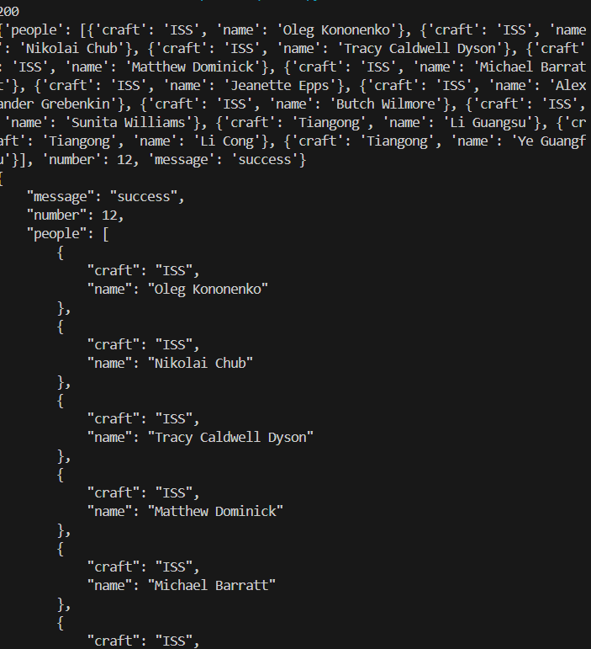
API for Fireball: https://ssd-api.jpl.nasa.gov/fireball.api?limit=20
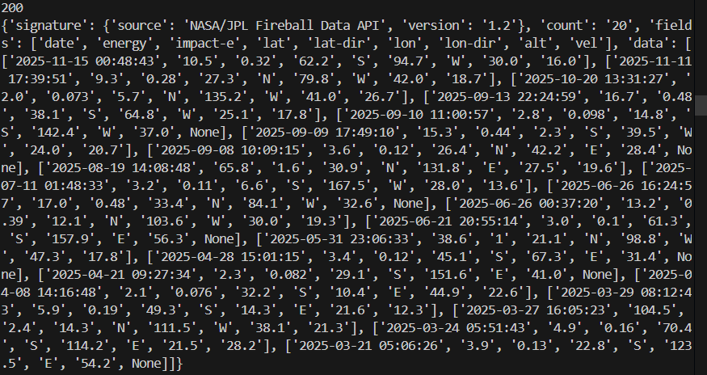
After formatting API:
